Using sed utility
1- Display the lines that contain the word “lp” in /etc/passwd file.
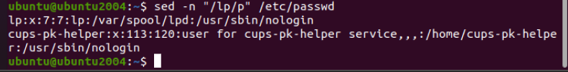
2- Display /etc/passwd file except the third line.
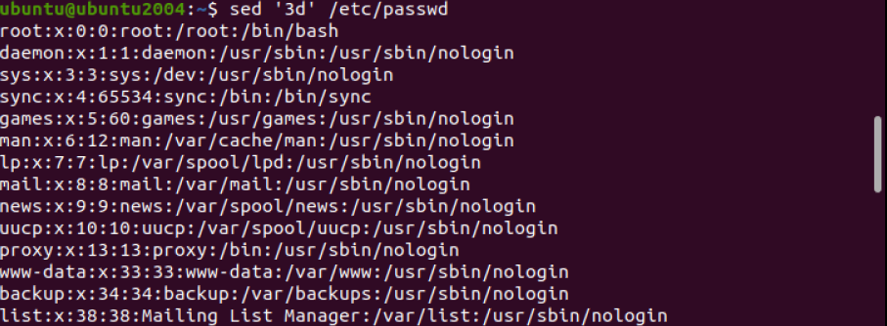
3- Display /etc/passwd file except the last line.
4- Display /etc/passwd file except the lines that contain the word “lp”.
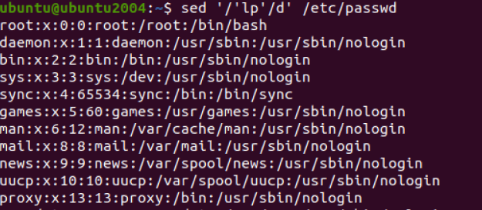

5- Substitute all the words that contain “lp” with “mylp” in /etc/passwd file
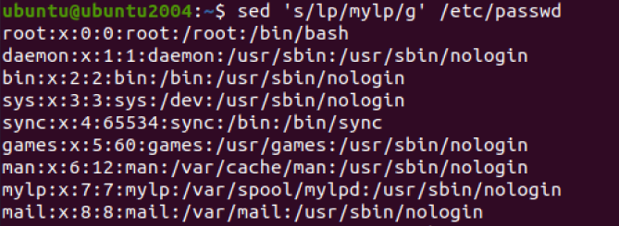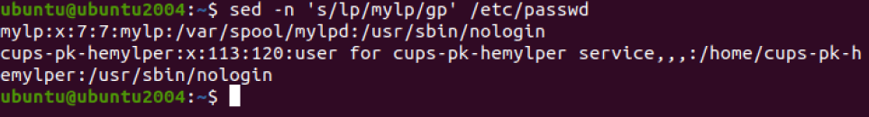

Using awk utility
1- Print full name (comment) of all users in the system.
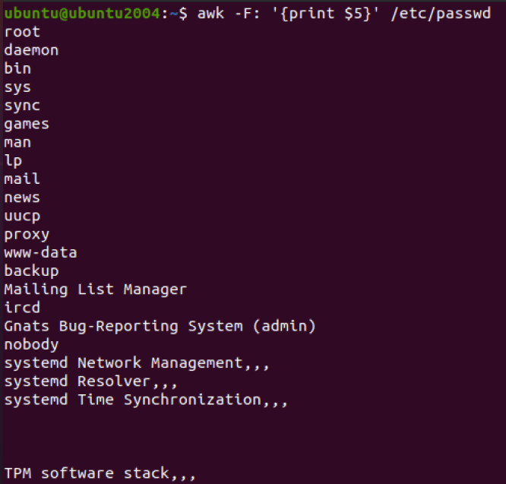

2- Print login, full name (comment) and home directory of all users.( Print each line preceded by a line number)
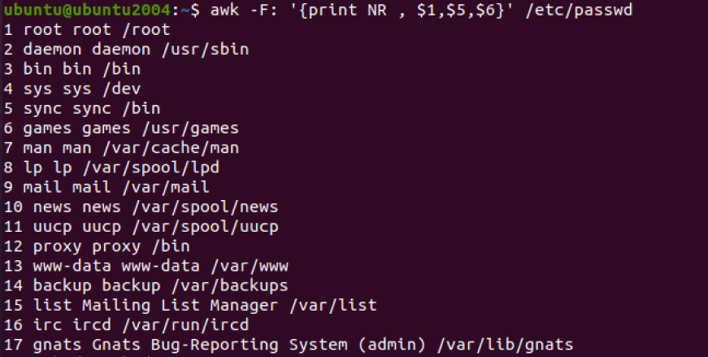
3- Print login, uid and full name (comment) of those uid is greater than 500
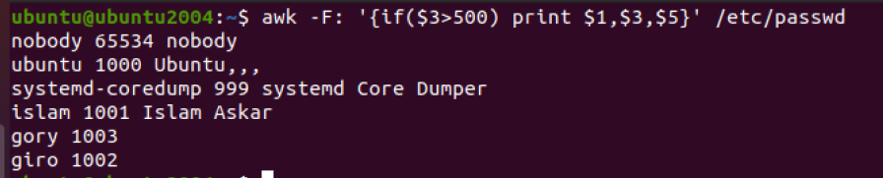
4- Print login, uid and full name (comment) of those uid is exactly 500
5- Print line from 5 to 15 from /etc/passwd
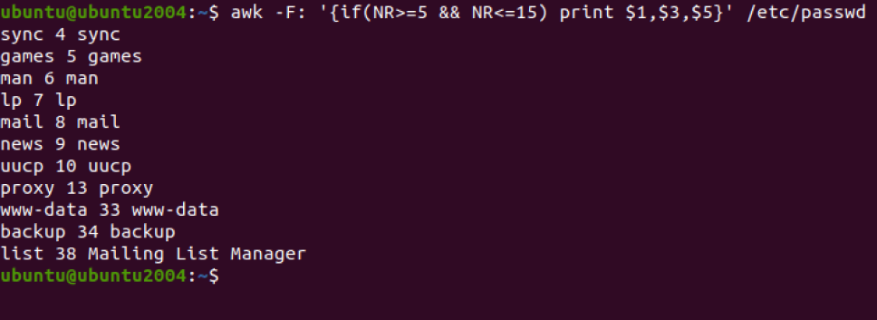

6- Change lp to mylp
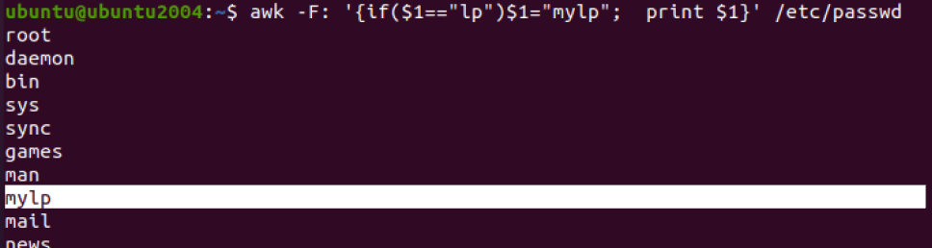
7- Print all information about greatest uid.
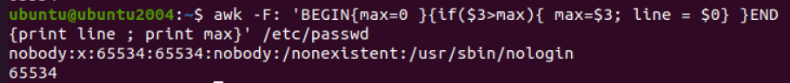
8- Get the sum of all accounts id’s.
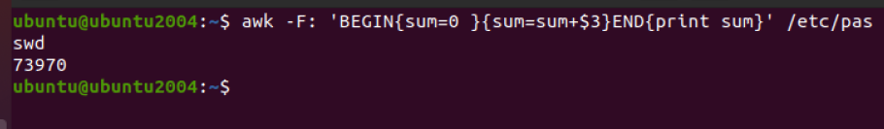

Bonus
1. Get the sum of accounts id’s that has the same group.
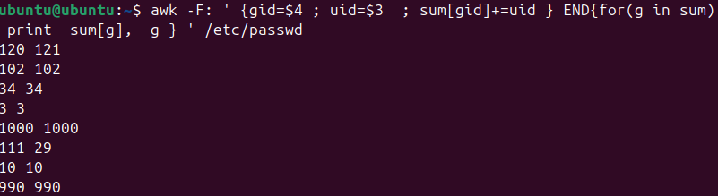
2 ……

